AWS Foundation Course – Exercises

Session - 2

Instructions to strictly follow:
1. Create a personal aws account.
2. Use only free-tier eligible AWS resources.
3. Stop/terminate/delete the AWS resources that you used at the end of the day Lab
4. Never keep the account credentials in GitHub/any other online platform.
5. Name the resource as empid-resourcename-action
6. Contact the instructor for region choice.

IAM (Identity and access management)

1. Create an HTC repository in AWS S3 (empid-bucketname-action).

2. HTC needs to Create an IAM policy to perform following operation in its repository.
a) Repository owner (IAM user) - Provide read / write access to repository and its content
b) Other Employee (IAM User) - Grant Permission to read content from the repository.
3. Create two Group for repository usage and test the above policy for the group users:
a) repository owner
b) repository users
Note: Two IAM users’ creation is sufficient for the above scenario.

4. Assume that the HTC application server (EC2) running in the cloud needs to access the repository. Create an IAM Service role to enable read access only.

5. Create an inline policy for the repository owner to do deletion operation.

Session - 3

Instructions to strictly follow:
1. Create a personal aws account.
2. Use only free-tier eligible AWS resources.
3. Stop/terminate/delete the AWS resources that you used at the end of the day Lab
4. Never keep the account credentials in GitHub/any other online platform.
5. Name the resource as empid-resourcename-action.
6. Contact the instructor for region choice.

Amazon S3 (Simple Storage Services)

1. In HTC repository, Upload three different objects (files). Note down the region where bucket is created.
Note : File size should not exceed 50Kb

2. Identify the repository bucket ARN.
3. To maintain the updated version of the files in the repository, enable bucket versioning. Test the feature.
4. HTC planned to host its repository content in the web. Illustrate the scenario as follows:
Create an S3 bucket to host a static website.
Configure the bucket to host a static website
Access the website pages from a browser.

5. Create a Life cycle rule for an HTC Repository bucket. [ For entire bucket and specific folders ]
Rules
1. All the current version of objects in the bucket should move to Standard-IA after 30 days
2. After 60 days it should move to Glacier.
3. All Objects should get deleted after 1 year.

6. Create a replica for the repository in the mentioned region.

7. Enable transfer acceleration feature for a repository.
8. Upload a employee.csv file to the repository bucket. Using S3 select, find the employee who has read more than 5 times.

EmpId | EmpName | No.Of Reads
1001 | Banu | 4
1002 | Priya | 6
1003 | Preethi | 7
1004 | Rokith | 3
1005 | Rohan | 5

9. Practice S3 AWS CLI commands for the above.
Session - 4

Instructions to strictly follow:
1. Create a personal aws account.
2. Use only free-tier eligible AWS resources.
3. Stop/terminate/delete the AWS resources that you used at the end of the day Lab
4. Never keep the account credentials in GitHub/any other online platform.
5. Name the resource as empid-resourcename-action.
6. Contact the instructor for region choice.

EC2
- Launch an EC2 Linux (free tier eligible) instance for HTC application hosting.
- Note the Public IP assigned to the above instance.
- To enhance the HTC application server, Create a new EBS volume (2GB). Type -> General Purpose SSDs
- Attach the new EBS volume to the instance launched.
- Connect to the instance using SSH.
(You should have putty and PuttyGen installed on your local PC)
- Install a web server in Linux instance and access using web browser.
Issue following command to install web-server
sudo yum update –y;
sudo yum install httpd –y;
sudo service httpd start;
sudo service httpd status;
sudo chkconfig httpd on;
- Edit inbound traffic rule in security group for HTTP port 80
- Open the browser and type your instance Public IP to access your web-server
- Detach the volume from the instance and attach to another instance.
10. Create a Snapshot from an EC-2 instance.
11. Create an EBS volume from a Snapshot and attach to an EC2 instance.
12. Create a AWS classic Load Balancer.
13. Create a Launch configuration and setup an Auto-scaling group.
14. Install AWS CLI and test with S3, EC2 and IAM services.
Session - 5

Instructions to strictly follow:
1. Create a personal aws account.
2. Use only free-tier eligible AWS resources.
3. Stop/terminate/delete the AWS resources that you used at the end of the day Lab
4. Never keep the account credentials in GitHub/any other online platform.
5. Name the resource as empid-resourcename-action.
6. Contact the instructor for region choice.

RDS
1. Create RDS instance in default VPC.
- Create relevant security group (Enable inbound rules for your ip address and allow mysql port traffic)
- Connect to your RDS instance through your EC2 instance using mysql client.
- Deliverables:
  - Create a customer-table in your mysql database in RDS-Mysql Instance.
  - Record the transaction history
Session - 6

Instructions to strictly follow:
1. Create a personal aws account.
2. Use only free-tier eligible AWS resources.
3. Stop/terminate/delete the AWS resources that you used at the end of the day Lab
4. Never keep the account credentials in GitHub/any other online platform.
5. Name the resource as empid-resourcename-action.
6. Contact the instructor for region choice.

DynamoDB Exercises
1. Create a NoSQL database table – Customer (customerId, customername, orderId, orderdate, totalpurchaseamount,)
2. Add 5 items to the table.
3. Test scan/query options like:
Filter the customers who have made the purchase > 15000.
4. Edit /delete items in the table.
5. Create a DynamoDB global table for customer table.
6. Try put/get item method to customer table using AWS CLI Commands.
7. Try query/scan using AWS CLI
8. Load the below JSON file into dynamoDB table using CLI commands.
{
"videos":[
{
"PutRequest": {
"Item": {
"authorid": {"S": "joe"},
"videoid": {"S": "video2"},
"length": {"N": "455"},
"name": {"S": "Somewhat Famous"},
"publicationdate": {"S": "2019-10-13"}
}
}
},
{
"PutRequest": {
"Item": {
"authorid": {"S": "joe"},
"videoid": {"S": "video3"},
"length": {"N": "454"},
"name": {"S": "Somewhat Famous"},
"publicationdate": {"S": "2019-10-14"}
}
}
}
]
}
Session - 7

Instructions to strictly follow:
1. Create a personal aws account.
2. Use only free-tier eligible AWS resources.
3. Stop/terminate/delete the AWS resources that you used at the end of the day Lab
4. Never keep the account credentials in GitHub/any other online platform.
5. Name the resource as empid-resourcename-action.
6. Contact the instructor for region choice.

AWS Lambda
1. Create a Lambda function to return a “Welcome to AWS World” message. Test it.
2. Create a Lambda function (Python) which inserts a log entry of the object that is being uploaded in S3 bucket into dynamodb table(s3objectlog).
3. Write Lambda Function (Python) to Read Data from S3 object (FileName: EmployeeDetails.csv) and write it into DynamoDB table(Table Name: Employee).
4. Write Lambda Function(Python) to Read Item Data from DynamoDB table(TableName: Employee) and display it in the lambda console.
5. Implement the following use case:
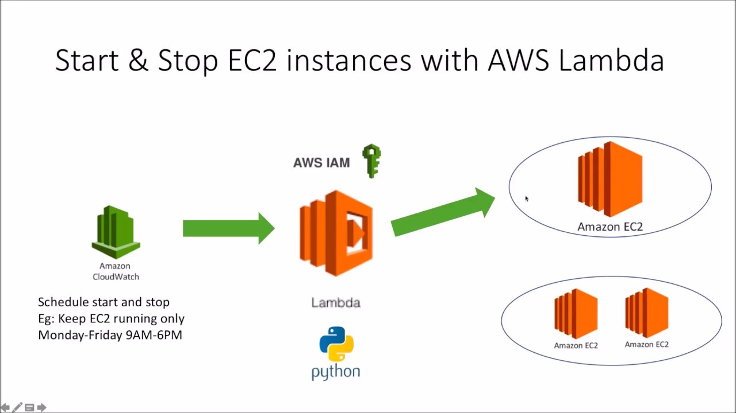

Session - 8

Instructions to strictly follow:
1. Create a personal aws account.
2. Use only free-tier eligible AWS resources.
3. Stop/terminate/delete the AWS resources that you used at the end of the day Lab
4. Never keep the account credentials in GitHub/any other online platform.
5. Name the resource as empid-resourcename-action.
6. Contact the instructor for region choice.

API Gateway
1. Create an test API using API gateway to fetch records from a DynamoDB table (TableName: Employee) using Lambda integration. Pass parameter to the API and fetch relevant records.
2. Deploy Simple Web Applications in AWS Lambda.
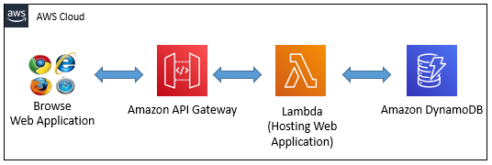
Session - 9

Instructions to strictly follow:
1. Create a personal aws account.
2. Use only free-tier eligible AWS resources.
3. Stop/terminate/delete the AWS resources that you used at the end of the day Lab
4. Never keep the account credentials in GitHub/any other online platform.
5. Name the resource as empid-resourcename-action.
6. Contact the instructor for region choice.

CloudTrail, CloudWatch
1. Create a Trail to record API calls in your aws account. Log all the events to an S3 bucket.
2. Validate the logs to check the integrity of CloudTrail logs.
3. Create a cloudwatch monitoring alarm if an EC2 instance CPU utilization is below 30%.
Session - 10

Instructions to strictly follow:
1. Create a personal aws account.
2. Use only free-tier eligible AWS resources.
3. Stop/terminate/delete the AWS resources that you used at the end of the day Lab
4. Never keep the account credentials in GitHub/any other online platform.
5. Name the resource as empid-resourcename-action.
6. Contact the instructor for region choice.

Simple Notification Service (SNS)
1. Create a Topic and add your mail id to subscribe to that topic. Test it by sending “Test Message”.
2. Create a cloudwatch monitoring alarm if an EC2 instance CPU utilization is below 30%. Send email notification and terminate the instance.
Simple Queue Service
1. Create a lambda function trigger (python) to pull the message from the SQS queue.

Session - 11

Instructions to strictly follow:
1. Create a personal aws account.
2. Use only free-tier eligible AWS resources.
3. Stop/terminate/delete the AWS resources that you used at the end of the day Lab
4. Never keep the account credentials in GitHub/any other online platform.
5. Name the resource as empid-resourcename-action.
6. Contact the instructor for region choice.

VPC
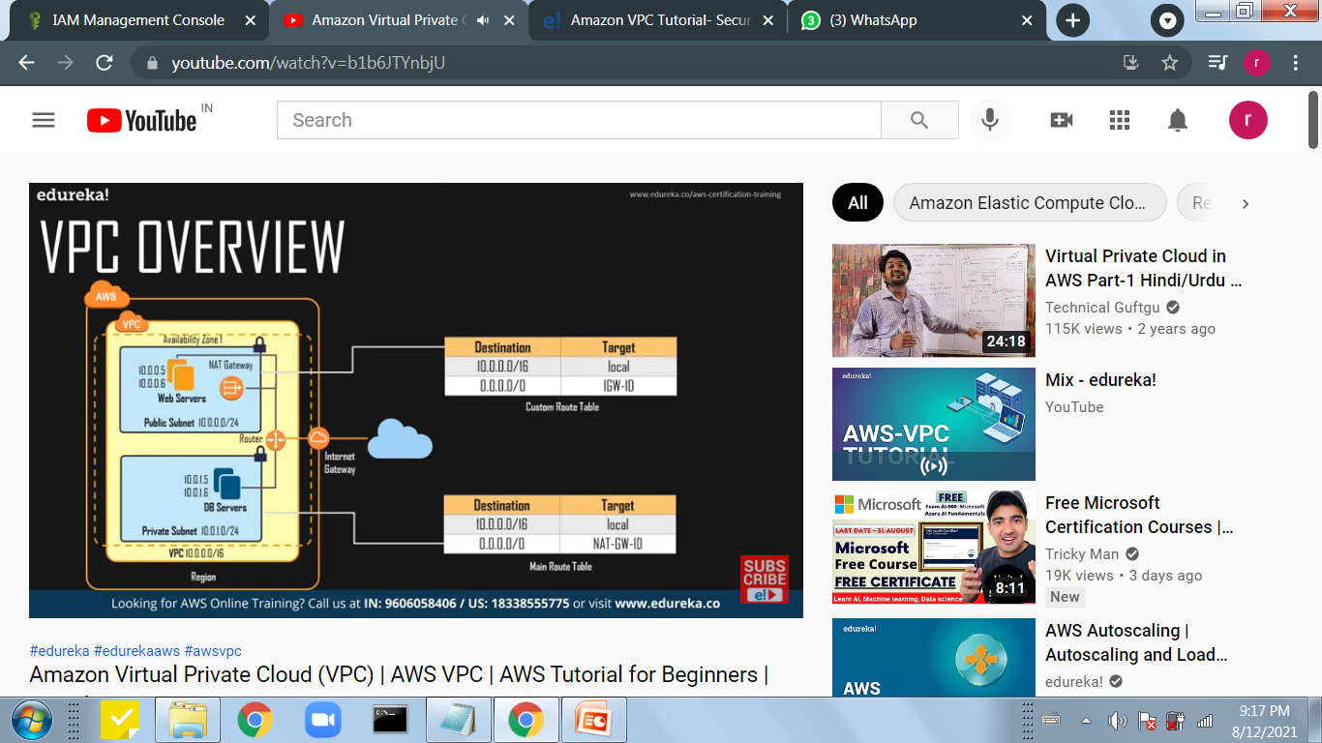
1. Illustrate the below use case:
Linux EC2 Instance

